Islamic Foundation School
Junior
Kindergarten

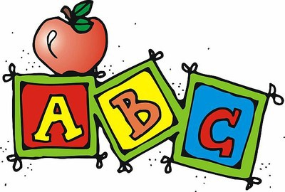

Curriculum
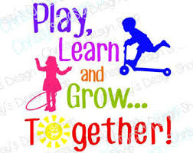
Night

2017-2018

Dear Parents,

Assalamu Alikum Wa Rahmatullah,

We would like to welcome you and your child to Junior Kindergarten, Islamic Foundation School! We are very honoured and excited to have your child in our class this year.
This curriculum package is intended to give you a clear picture of the learning goals and expectations for your child. So it will be an extension for our classroom to involve parents in learning, activities and academic progress of their children.
We encourage you to contact us if you have any questions or concerns at any time. We are looking forward to a wonderful and exciting year with you and your child Insha Allah!

Sincerely,
The Junior Kindergarten Teachers.

Language- Writing and Reading
To foster the language development necessary for literacy, our Full-Day Early Learning–Kindergarten programs is rich in language-oriented activities and resources, which are relevant to the lives of young children, and provides opportunities for thinking, problem solving, and experimenting.
The Full Day Early Learning Program Draft Document p.18
- Literacy : In our literacy block we will do both reading and writing. • We work as a whole class, in small groups and with each student individually. •Activities are planned according to the needs and abilities of the children.• Literacy is embedded throughout our day.
- Writing: Working together in “Shared” & “Interactive” writing• Whole class mini-lessons• • Time for one-on-one conferencing•
- Reading Time: •Read to Self •Partner Reading •Shared Reading •Guided Reading •Read Aloud •Reading Buddies •Take Home Books •Poetry Songbooks

Mathematics

Children learn best through active involvement, and this is especially true in math where abstract symbols prevail. So our kindergarten teachers create a learning environment that gives context to math concepts, provides hands-on learning, and emphasizes the use of math talk. We follow a variety of instructional strategies, including whole group lessons, collaborative problem solving in partners or small groups.

Our math program emphasizes a hands- on, problem-solving approach to learning math concepts. • We also work on our calendar skills which include: the days of the week, the months of the year, the concepts of yesterday, today and tomorrow, and various counting skills. • Units for Math: Numbers; Shapes and Patterns; Sorting, Ordering and Comparing; Measurement; Joining and Separating Numbers; Show What We Know .
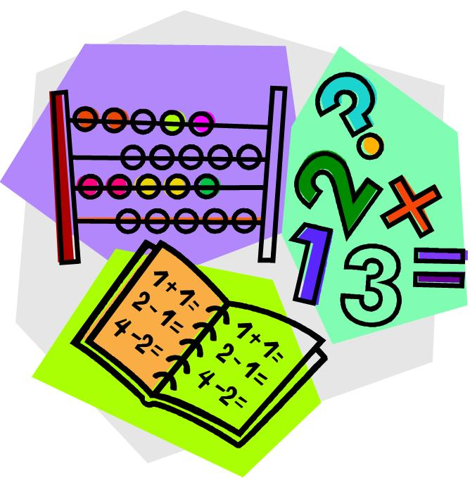

Science and Social Studies
We provide our students with the opportunity to explore natural elements in the classroom (e.g., growing plants). We engage students by including environmental issues (e.g., recycling, composting). Which can provide students with the opportunity to become environmentally conscious and responsible citizens.
Our activities are designed to guide students to become effective problem solvers. We will also be having Scientist in School Workshops for the students. Topics to be covered are as follows:
- Five senses
- Air, water, land
- Simple machines
- Temperature, warm, cold
- Ice freezes / melts
- Living and nonliving things
- Sink and float
- Water transportation
- Hibernation
- Ocean creatures
- Habitats
- Life cycle of a butterfly
- Exploring spring items, being environmentally friendly
- Solids & liquids
- Building structures using shapes
- Sequencing
- Investigating our local habitat

Visual Arts

Young students love to express themselves creatively. Thus the arts provide a means to introduce new concepts and to have students demonstrate their knowledge.
Art allows all students to feel success and satisfaction with their own ideas and creations. Topics to be covered are as follows:

- Free art exploration
- Family portraits
- Leaf related art works
- Finger painting
- Mixing colours
- Recognize and describe simple patterns
- Role playing
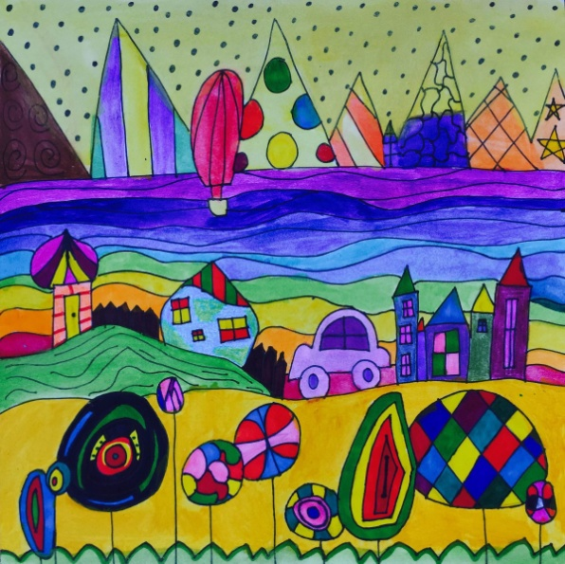
- Nursery rhymes
- Dramatic centers
- Arts and crafts

Health and Physical Education
In physical education students will learn healthy habits in exercise while having fun through the use of games and other activities. They will learn to take turns, develop gross motor skills, follow directions, and work in a team or in a pair. Skills to be taught are:
- Fundamental movement skills
- Fine motor centers
- Healthy lunches, gym and playground safety
- Practicing throwing skills
- Gross motor games
- How to move in my environment
- Free play
- Skating games
- Outdoor plays
- Bean bag games
- Demonstrate balance
Islamic Studies
Aside from the curriculum, we will be teaching Islamic Studies to the student daily. Areas of concentration are as follows:
- Few Quranic surahs  - Seerah (Nasheed)  - Iman (5 pillars of Islam)  - Belief in the day of judgement | - Identify self as a Muslim  - Other prophets  - Angels  - Forbidden and permitted items in Islam.

Parent’s Role in Child’s Learning:

How can you help your child learn? :
• Talk about the events of the day.• Ensure that your child has a wide range of experiences to talk and write about.• Read to your child every day.• Play games with your child.• Make sure your child gets enough sleep (approximately 10 hours for a 5 year old) and eats breakfast.
Helping at home with reading:
• Reading aloud to your child is the single most important thing you can do to help him or her become a successful reader.• Read at Home Recording Sheet
Helping at home with writing:
• Provide written “tools” and a table or desk to work at.• Encourage young writers by asking them to tell you about their writing/drawing.• Let them hang up their work, or send it to someone special.
